Jamalpur Flower Market:
Research & Insights
  - Understanding the economic role of informal vending in Ahmedabad’s flower market

Abstract
This paper examines the economic role of informal vending around Jamalpur Flower Market in Ahmedabad, focusing on its relationship with the 32 permanent shops inside the market. I carried out exploratory qualitative design research over four to five days, visiting at different times between approximately 4:00 AM and 11:00 PM. The study combined interviews and conversations, shadowing, direct observation, card sorting, stakeholder mapping, and desk research. Fieldwork suggests that some roadside vendors buy flowers from permanent shops and resell them outside, where buyers can stop, purchase, and leave without navigating the crowded market. This creates an additional route from the permanent shops to everyday buyers and supports livelihoods connected to flower selling and related services. The arrangement is also precarious: roadside vending contributes to congestion and vendors may be asked by municipal or police vehicles to move. I argue that informal vending is economically important in the functioning of the local market network, while recognising that this study did not measure its total monetary contribution or establish that it stabilises market-wide revenue. The design outcome, Ragdoll Economics, translates the observed uncertainty around supply and demand into a game concept.
Keywords: informal economy, street vending, flower market, Ahmedabad, qualitative design research, economic interdependence
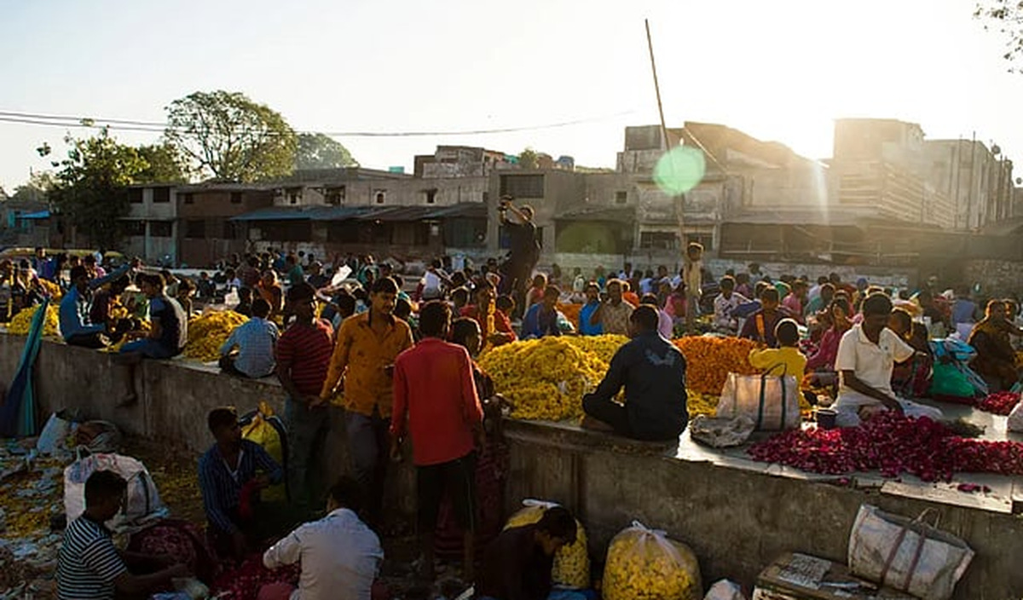
Figure 1. Flower trading in the open-ground market during a field visit. Photograph by the author.

1. Introduction and context
Jamalpur Flower Market is one of Ahmedabad’s main hubs for flower trading. The Ahmedabad Municipal Corporation’s heritage listing records that the market began operating in 1989 and describes a shift from wholesale activity in the early morning to retail sales later in the day (Ahmedabad Municipal Corporation [AMC], n.d.). Reporting by Bhadra (2023) describes 32 permanent stores, with the busiest wholesale period concentrated in the early morning. The market’s history is linked to Fulgali, near Teen Darwaja, where flower sellers traded before a dedicated market space was established. As the number of sellers and buyers grew, space and traffic became practical concerns (Bhadra, 2023; Jani, 2026).
I approached Jamalpur not only as a place where flowers are bought and sold, but as a network of work. Permanent shops, roadside vendors, garland makers, buyers, transport workers, and small service providers all take part in its daily activity. The permanent shops are easier to identify as a fixed market structure. The activity around them is less settled. Sellers occupy the outside ground or roadside at different times, buyers stop along the street, and other businesses appear around the flow of trade. These activities may look separate when viewed spatially, yet the fieldwork showed connections between them.
The focus of this study is the economic importance of the informal market. Some roadside vendors buy flowers from the permanent shops and resell them outside. This matters because their role is not limited to selling their own stock: they also provide a route through which flowers move from the shops to buyers who prefer a quick purchase. At the same time, roadside vending occupies space also used by moving and parked vehicles. The same arrangement can make buying easier while contributing to congestion and leaving roadside sellers vulnerable to removal.
The purpose of this paper is to explain these relationships without treating informal vending as either a problem to be cleared away or a solution that benefits everyone equally. The study supports a qualitative argument about economic contribution and interdependence. It does not calculate the total value of informal trade, measure the effect on shop revenues, or establish that the entire market depends on roadside vendors to remain profitable.
The photographs from my field visits show both sides of this setting: the open trading area and the permanent shops inside the market. They provide visual context for the relationships discussed in the following sections.
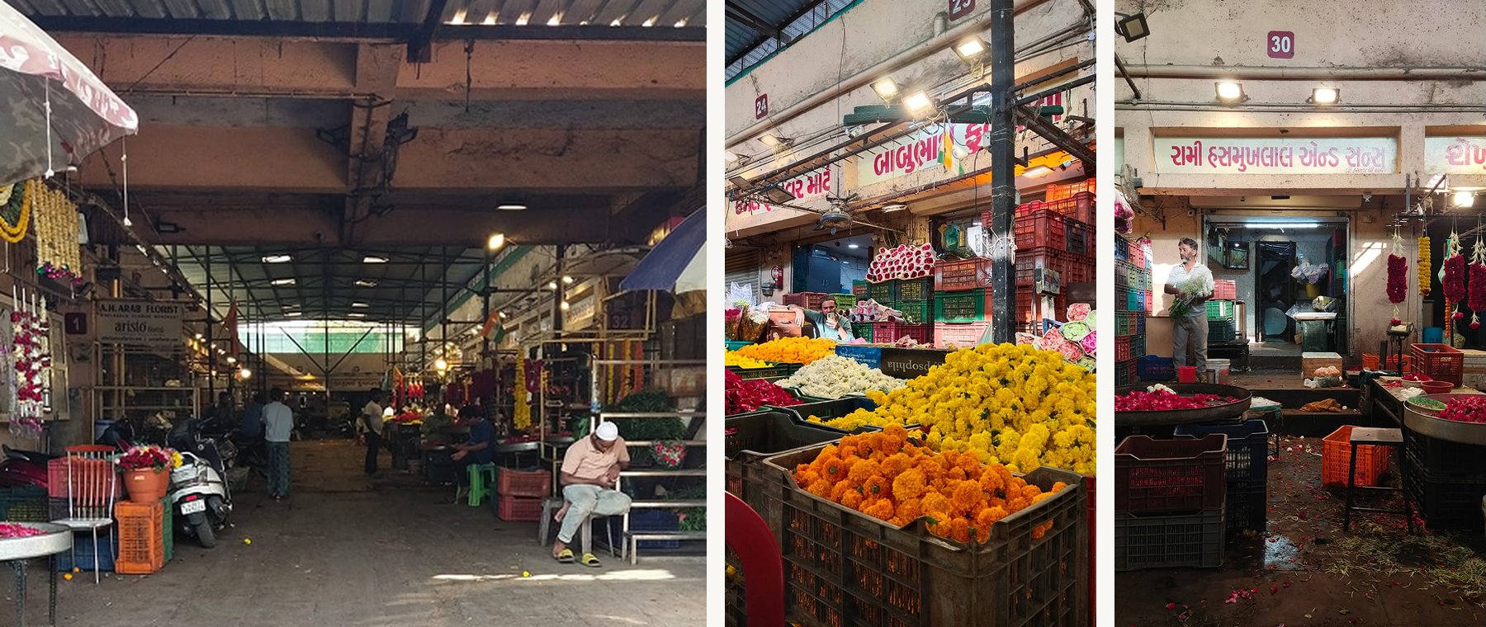
Figure 2. Views inside the market hall, including the central aisle, flower stock, and a permanent shop frontage. Photographs by the author.

2. Research question and objectives
“Does the informal market play a significant role in the Jamalpur flower market and the local economy? If so, how?”
I retained this question because it keeps the focus on the economic role of informal vending, rather than turning the study into a proposal to redesign the market’s physical layout. The work aimed to understand how formal and informal selling operate across the day; how flowers move between permanent shops, roadside vendors, and buyers; what makes roadside selling useful to customers; and what economic, spatial, and regulatory pressures shape vendors’ work.
For analysis, I looked at three connected issues: the movement of goods and money between participants; the convenience and accessibility created by roadside sales; and the tension between these benefits and the uncertainty of selling from public space. These issues provide the structure for the findings below.

3. Contextual literature and desk research
Research on informal vending cautions against treating the informal economy as entirely separate from formal businesses. In their study of street vendors in Delhi and Phnom Penh, Sekhani, Mohan, and Medipally (2019) describe the close relationship between formal and informal activity through vendors’ narratives and inventory logistics. Their work is not evidence about Jamalpur itself, but it offers a useful way to examine the movement of goods and the relationships that allow informal businesses to operate near formal ones. I used this perspective to ask where roadside vendors obtain stock, whom they sell to, and how their work connects to the permanent market.
The wider policy context also matters. India’s Street Vendors (Protection of Livelihood and Regulation of Street Vending) Act, 2014 sets out a framework that combines the protection of street vendors’ livelihoods with the regulation of vending activity (Government of India, 2014). Gujarat’s agricultural marketing framework is a separate but related area. PRS Legislative Research’s review of the Gujarat Agricultural Produce Markets (Amendment) Ordinance, 2020 discusses market areas and licensing for agricultural produce trading (PRS Legislative Research, 2020). Neither source, on its own, establishes the exact permissions held by each seller in Jamalpur or whether a particular roadside location is permitted under local rules. I therefore use these sources only to understand the broader regulatory context, not to make a legal determination about individual vendors.
Local reporting provides a more specific picture of the market. The Indian Express reports 32 stores, a strong early-morning wholesale period, and flowers arriving from both nearby growing areas and other parts of India (Bhadra, 2023). It also reports that approximately 500 nearby households purchase flowers from the market to make garlands. This suggests that the market’s role extends beyond transactions inside the permanent shops, although the figure comes from the newspaper’s reporting and was not verified through my own household survey. The AMC heritage listing places the market’s start in 1989 and describes the shift from wholesale to retail over the day (AMC, n.d.). Knocksense (Jani, 2026) provides a more recent popular account of the market’s connection with Fulgali, while Arora (2026) offers a supplementary overview of its trading role. I treated these popular descriptions as context rather than evidence for the specific roadside arrangements observed. The analysis of roadside vending in this paper is grounded primarily in my fieldwork.
Across these sources, I found a useful distinction between what can be described from existing material and what needs direct evidence. Public reporting can establish broad historical and market context. It cannot tell us how often municipal vehicles ask roadside vendors to move, how common commission arrangements are between shop owners and vendors, or how much income informal selling contributes to the market as a whole. Those questions require systematic local records or a larger and more structured study.

4. Research methodology
I carried out this study as part of a collaborative design-research project. I use first person when discussing my approach and interpretation, and describe collective field activities where they were carried out as a team. The study was exploratory and qualitative. I wanted to understand the relationships and working conditions within the market, rather than produce a statistically representative account of all sellers.
Fieldwork took place over four to five days, with visits at different times between approximately 4:00 AM and 11:00 PM. These were visits across different days, not continuous observation over a single nineteen-hour period. The timing allowed us to observe differences between the early wholesale activity, morning sellers, and later roadside selling. Methods included interviews and informal conversations, shadowing, direct observation, stakeholder mapping, card sorting, and desk research.
We conducted interviews with three formal traders and four informal vendors. We also spoke informally with approximately three to four buyers encountered at the market. Across the visits, we had conversations with people connected to around five or six of the 32 permanent shops, but not every conversation was a full interview. Access to shop owners was limited because they were occupied with running their businesses. In several instances, workers were more available to speak but had less information about broader business operations, which were generally handled by owners. This shaped what we could learn about purchasing, commissions, and the commercial relationship between shops and roadside vendors.
We shadowed four vendors: two working in formal shops and two informal sellers. This helped document the rhythm of their work, including when they arrived, how they obtained flowers, when they prepared garlands, and when sales became busier. The routines recorded in the project materials describe typical sequences rather than verbatim life histories. Direct observation was also used to understand the physical relationship between the permanent market, outside selling areas, the road, and buyers who stopped briefly to purchase flowers.
I also made a rough plan of the site to record the relationship between the main hall, the outside ground, roadside selling areas, the single entry point, and the municipal toilet across the road. This was an observational sketch, not a measured architectural plan. The original sketch labels 31 formal shops; I later used 32 as the corrected count in the final analysis.
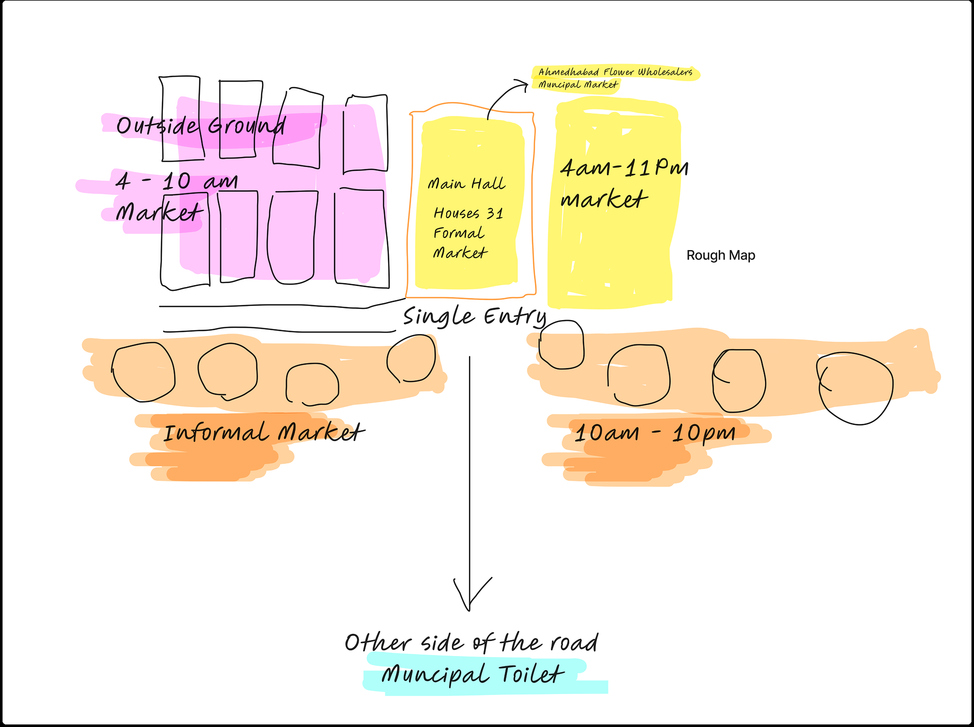
Figure 3. Original field sketch of the market layout. The sketch labels 31 formal shops; the corrected count used in this paper is 32. Approximate and not to scale.
For the card-sorting exercise, participants individually ranked cards related to expenses and aspects of selling. The cards included stock purchases, transport, ice, lighting, and garland thread, along with prompts about seller challenges and buyer priorities. A board image remains in the project material, but a complete set of individual rankings is not available. I therefore describe the exercise as a method used to structure conversations, not as a source for a definitive ranking of expenses. Stakeholder mapping was used to identify visible and less-visible participants, then consider their influence, interest, and participation in the market.
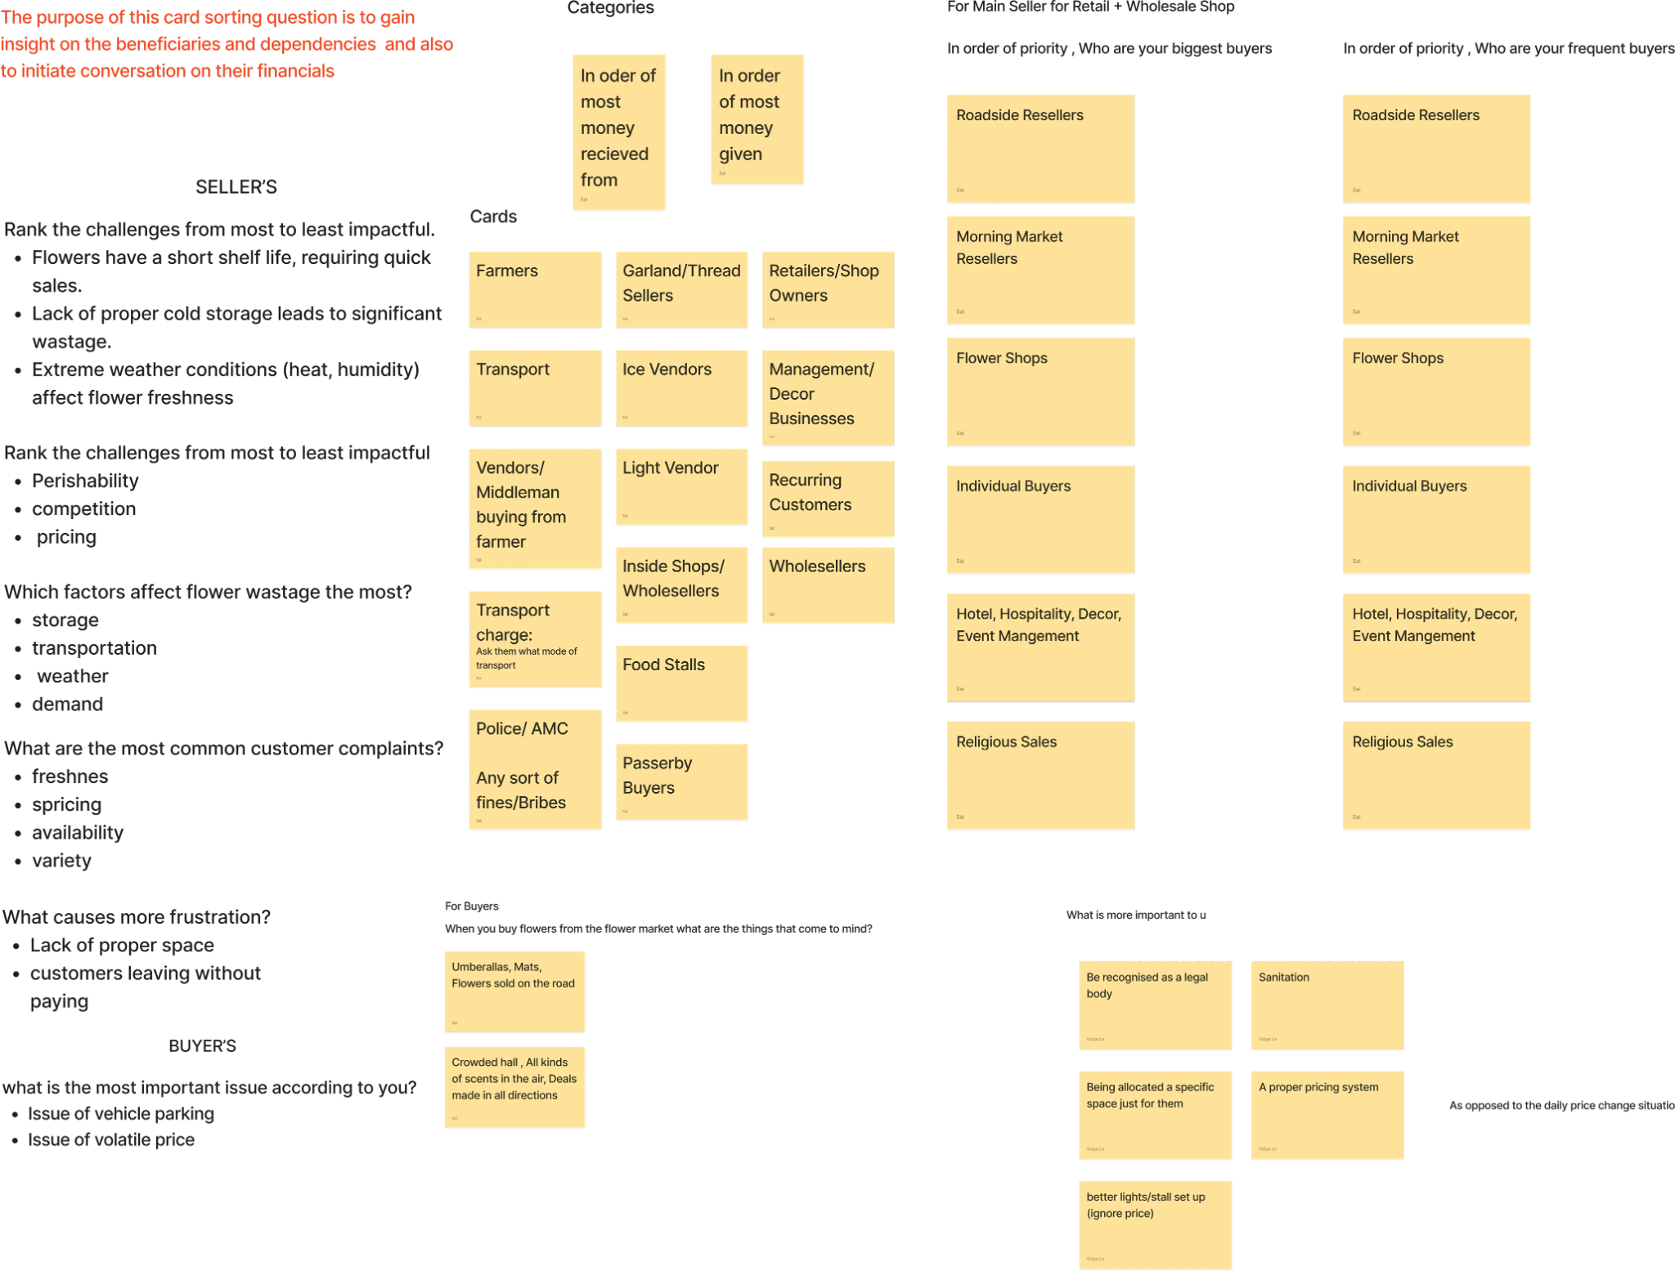
Figure 4. Card-sorting material retained from the project. It documents the prompts and categories used; the complete individual ranking data were not retained.
Desk research included local reporting, the AMC heritage listing, a legislative note on Gujarat’s agricultural market framework, and research on informal vending. The evidence has several limits: the sample was small, owner access was uneven, no sales or income records were collected for independent verification, and the study did not undertake a legal audit. The findings should be read as qualitative insights from the participants and situations observed, not as claims about every trader or the total economy of Jamalpur.

5. Findings and analysis

5.1 A market organised by time and location
The market did not operate as one uniform space throughout the day. The permanent shops inside the market formed its stable structure, while activity outside changed according to time. Our observations and field map distinguished early outside selling, approximately 4:00-10:00 AM, from the roadside activity associated with resellers and garland makers later in the day, approximately 10:00 AM-10:00 PM. These time ranges are approximate. They reflect the periods recorded during our visits, rather than a formal schedule that applies to every seller.
Early trading was shaped by bulk movement and the quick handling of stock. Later activity included vendors who continued selling to individuals and preparing garlands. Permanent shop activity also changed over the day: wholesale transactions were concentrated early, while retail purchases continued later. This rhythm matters because different groups used the same market environment for different purposes. A map that shows only the permanent shops would miss a large part of how flowers moved to buyers and how the surrounding street was used.
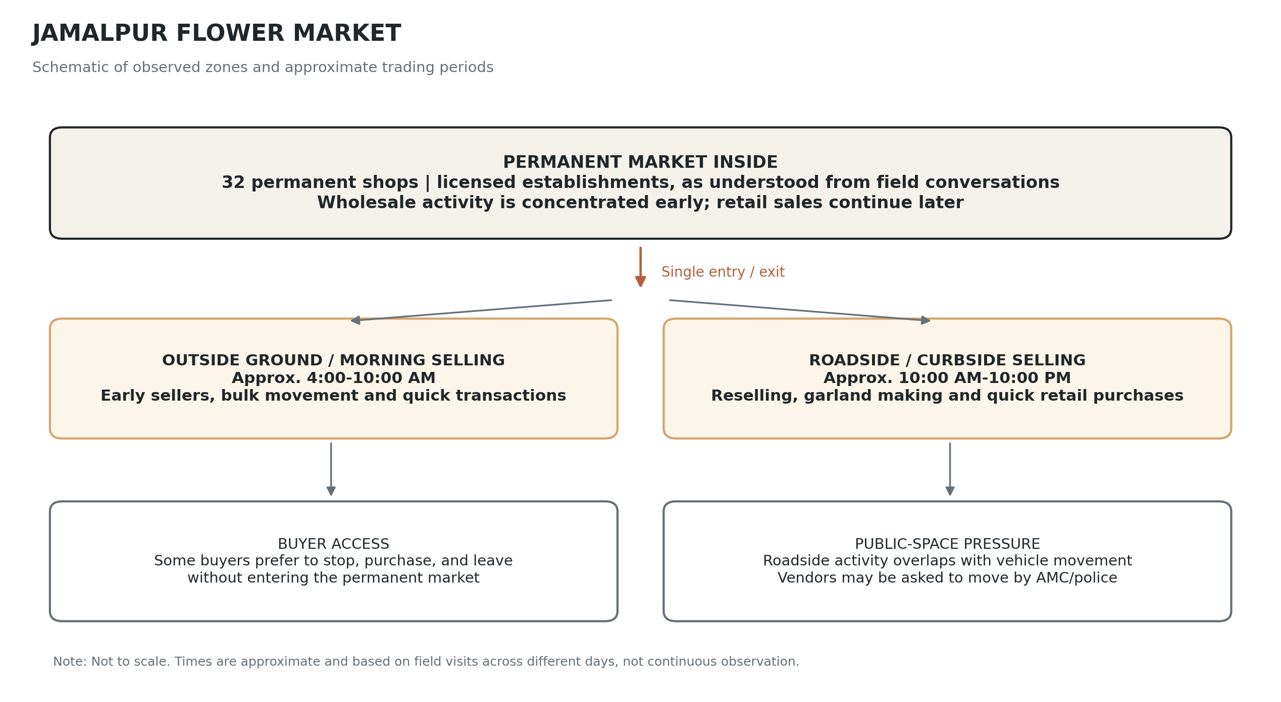
Figure 5. Schematic of observed market zones and approximate operating periods. Redrawn from the field map and visit notes; 32 permanent shops shown as the corrected count. Not to scale.

5.2 Informal vendors connect the permanent shops to buyers
One of the clearest relationships in the fieldwork was the movement of flowers from permanent shops to informal vendors. The permanent shops acted as an important source of stock. Some roadside vendors had fixed buying relationships with shops inside the market, purchased flowers in bulk, and then moved outside to sell. The field account records purchases of roughly four to five kilograms for some roadside sellers; this is an observed or reported quantity from the study, not an average for all vendors.
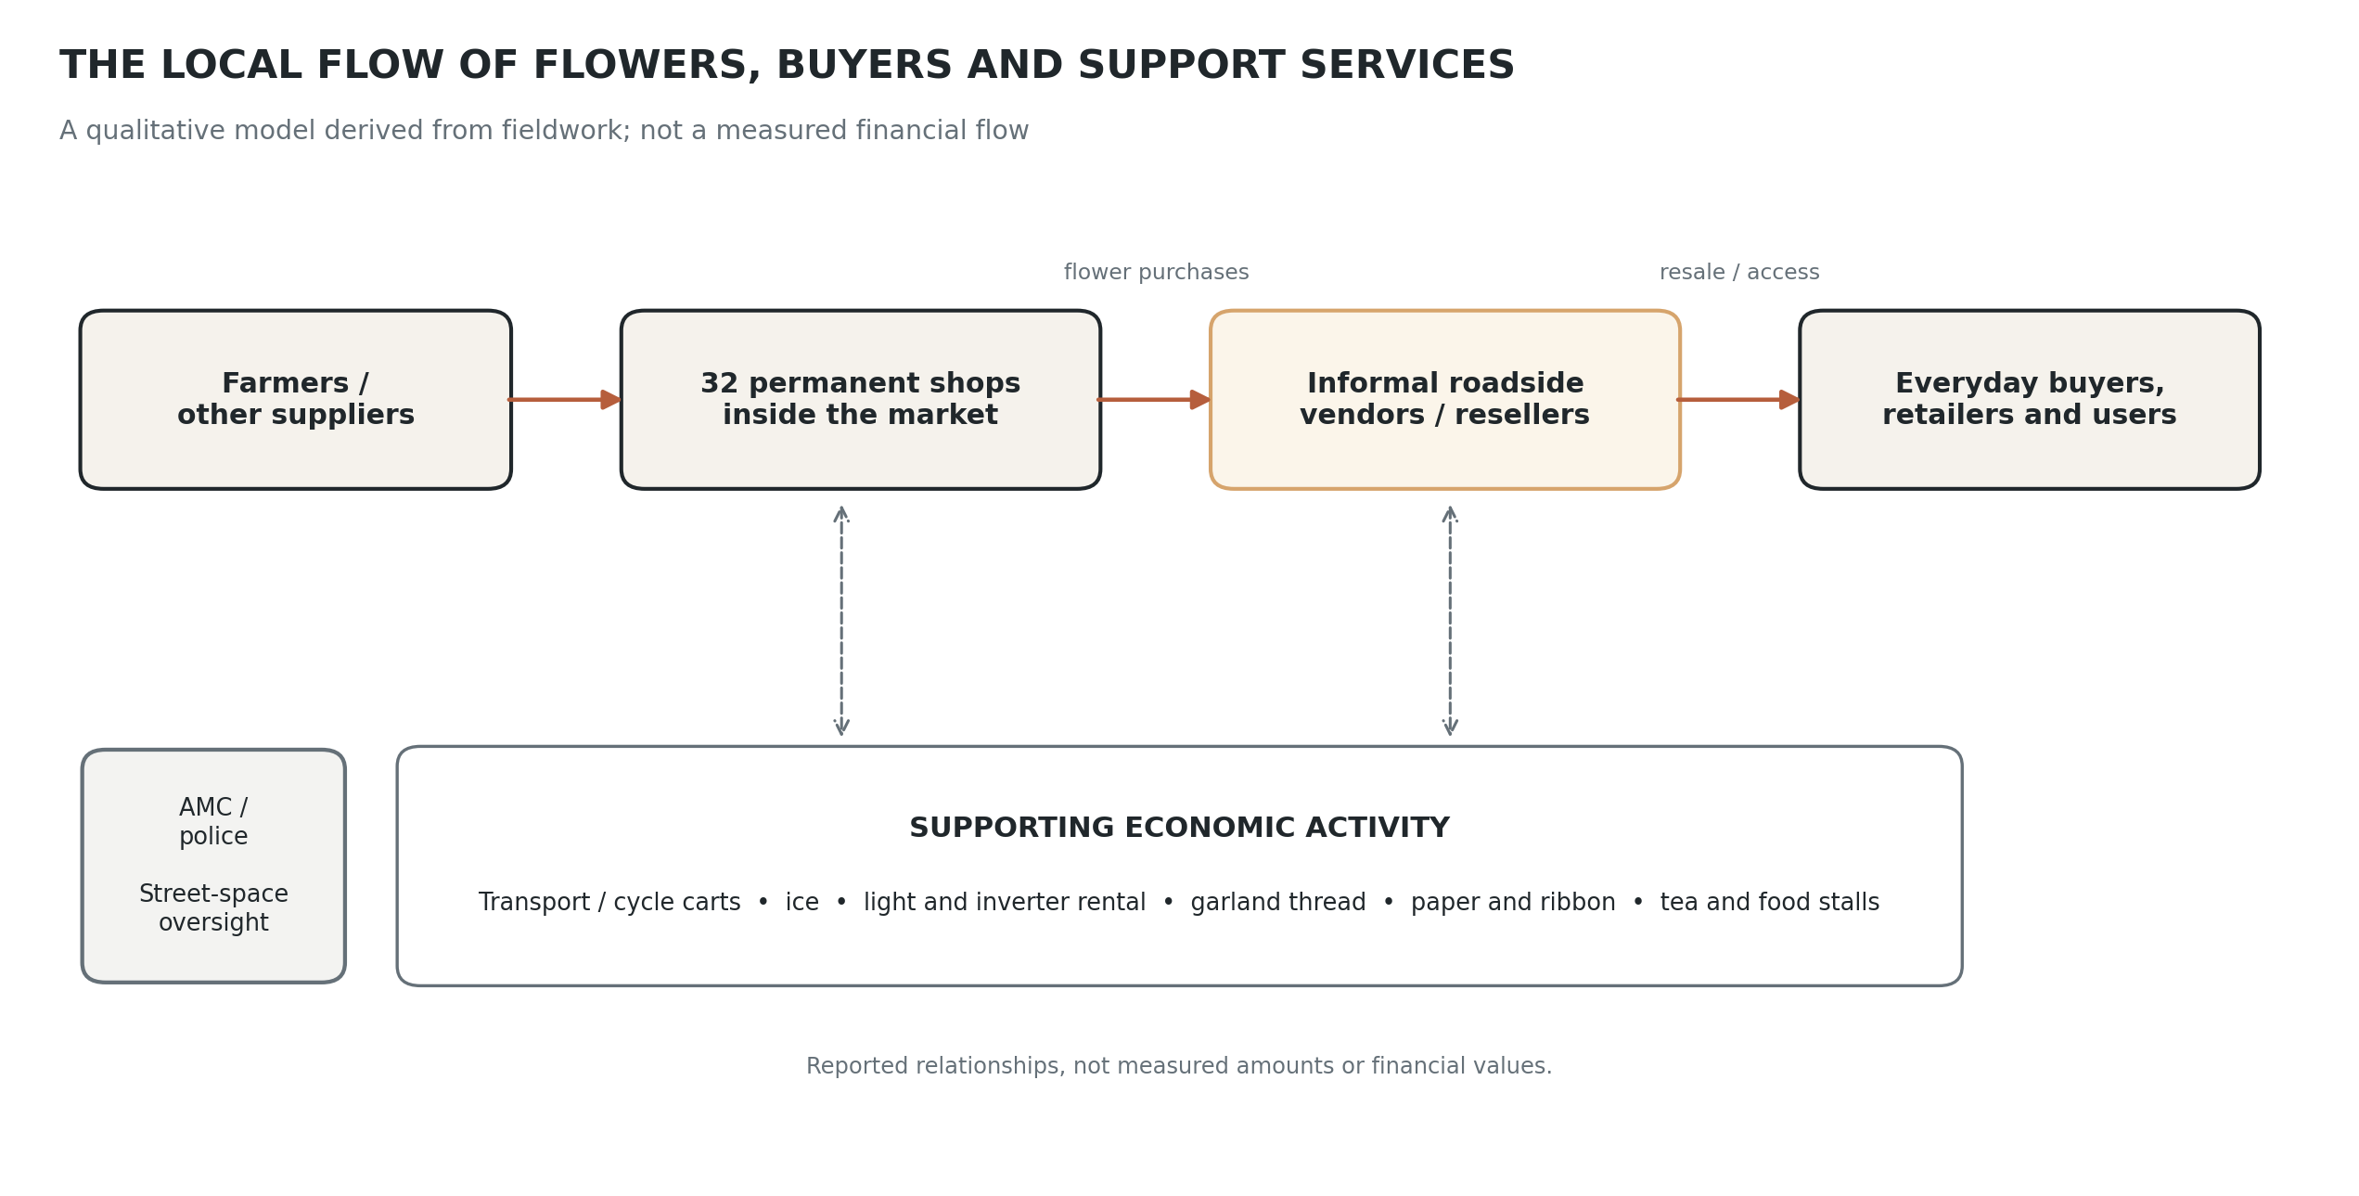
Figure 6. Qualitative map of the flower trade and supporting services. Based on fieldwork and stakeholder mapping. Arrows indicate reported connections, not measured quantities or verified financial flows.
The difference between the two selling settings is practical. Inside the market, buyers may need to enter, locate a shop, speak with the seller, select flowers, and then leave. For buyers who are already travelling by scooter or another vehicle, the roadside setting offers a shorter exchange. A person can stop, buy flowers, and continue on the way. This creates a selling channel that the permanent shops do not provide in exactly the same form.
The relationship is therefore not simply formal shops competing with informal vendors. At least in the cases recorded, informal sellers sourced flowers from the shops and resold them to a different flow of buyers. This may create additional turnover for permanent sellers while supporting the livelihood of the roadside vendor. It also moves flowers into a more visible and accessible setting. However, I did not have access to transaction records that would show how much revenue these purchases generated or what share of a shop’s sales went to roadside vendors. The evidence supports interdependence, but not a quantified estimate of its value.
Field conversations also indicated that some permanent shop owners received commissions from roadside vendors in connection with permission to sit outside. I could not establish how widespread this arrangement was, how the amount was calculated, or whether it was formally documented. It should not be assumed to apply to every shop or seller. Even with that limitation, the finding complicates a simple division between formal and informal trade: a vendor may depend on a permanent shop for stock and also rely on an arrangement with that shop to occupy a useful selling position outside.

5.3 Convenience creates value and congestion at the same time
The roadside market makes flowers more accessible and visible. It brings sellers closer to passing buyers and supports spontaneous purchases. In the fieldwork, the stop-buy-leave pattern stood out as a practical reason for roadside selling. Buyers who did not want to park, walk into the market, negotiate inside, and return to their vehicle could make a quick purchase from the curb. This was not only a matter of preference; it affected where the transaction took place.
The same convenience contributes to the physical pressure around the market. Vehicles stop near the sellers, pedestrian and vehicle movement overlap, and the road has to accommodate both commerce and circulation. The permanent market also has a constrained entry and exit, which adds to the feeling of crowding. Roadside selling therefore supports access but also competes for space. Describing it only as beneficial would ignore the traffic problem; describing it only as an obstruction would ignore the buyer behaviour and economic activity that keep the roadside market in use.

5.4 Price uncertainty and the costs of remaining in business
Price variation was a recurring issue in the research material. Buyers expressed concern that flower prices changed across sellers and days. Existing reporting from Jamalpur also describes daily price variation linked to supply, demand, and seasonal occasions (Bhadra, 2023). Festivals, religious events, weddings, and weather can alter demand and availability, while flowers themselves are perishable. A seller who cannot move stock quickly may have to reduce the price or risk losing it. This is part of the context in which informal vendors make purchasing and selling decisions.
The card-sorting exercise brought attention to the costs that sit around a flower sale. The available cards included stock purchases, commuting or transport, ice, light rental, and garland thread. These expenses show that the cost of selling is broader than the flowers themselves. Some sellers also rely on external services, such as transport or cycle carts to move stock and lighting to work through early or late hours. The stakeholder map included other supporting activity such as tea and food stalls and suppliers of paper and ribbon.
Because the original individual rankings were not retained in a complete form, I cannot claim that participants consistently placed one expense above another. What the exercise supports is a more modest insight: vendors have to manage several small operating costs alongside uncertain demand and a product that loses value when it is no longer fresh. These conditions may limit their ability to absorb losses, though the study did not collect enough comparable income and expense data to estimate margins.

5.5 Informal does not mean outside the economy; it means a different position within it
The fieldwork suggests that the informal market contributes to the wider economy through several connected activities. Roadside vendors purchase stock, resell it, serve buyers seeking quick access, and create demand for related services. The economic activity also extends to garland makers and households who buy flowers to prepare products for sale. The Indian Express reports that approximately 500 nearby households purchase flowers from the market for garland making, offering wider context for these connected livelihoods (Bhadra, 2023). My study did not independently count those households, but the report supports the idea that Jamalpur serves an economy larger than the set of permanent shops alone.
The roadside vendors’ position is nevertheless uncertain. During fieldwork, we learned that municipal or police vehicles sometimes came to the road and asked sellers to move away from the curb, usually in the context of traffic and public-space use. This did not appear to happen constantly during our visits, but the study was too short to estimate the frequency of enforcement. The fact that vendors continued operating between such interventions should not be confused with official permission to occupy the space.
As I understood the situation from field conversations, the 32 permanent shops inside the market had the relevant licences, while roadside sellers did not have equivalent permission to use the curb. That description reflects our field understanding, not an independent legal audit of every vendor’s status. The AMC and APMC should not be treated as interchangeable, and the applicable rules for a permanent shop, a trader dealing in agricultural produce, and a street vendor using public space may differ. The study does not determine the legal position of any individual seller.
This leaves the market with an uneasy but functional arrangement. Roadside selling serves buyers and can support the shops from which vendors purchase flowers. At the same time, it is exposed to removal because it relies on space that is also needed for movement. Benefits are not distributed evenly: a buyer gains convenience, a permanent shop may gain a resale transaction, and the roadside vendor earns a livelihood while carrying the risk of being asked to move.
I revisited the original stakeholder and power–interest maps to make the relationships easier to read together. The revised map groups the actors around core trade, supply and operations, public space and governance, and demand and context. These groups overlap in practice; the diagram is a qualitative synthesis, not a measure of each stakeholder’s economic influence.
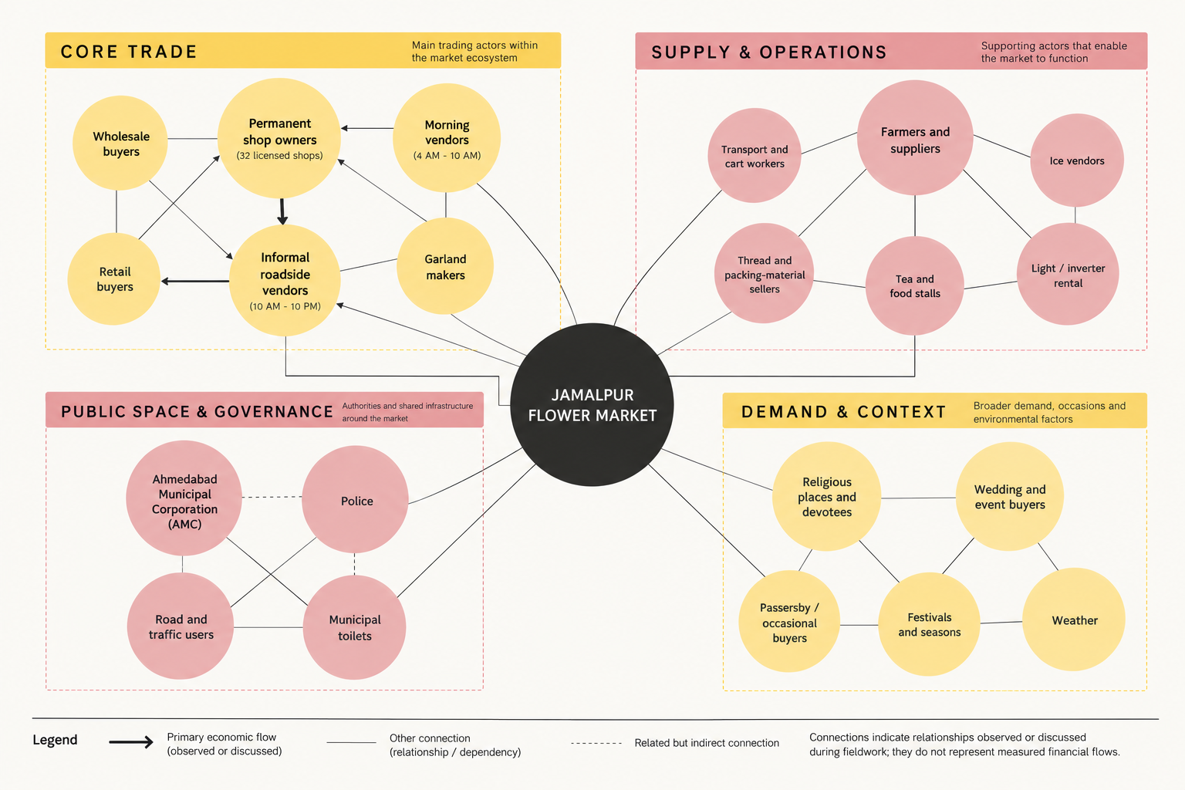
Figure 7. Revised stakeholder map based on the original fieldwork mapping. Actor groups are simplified for readability; connections indicate relationships observed or discussed, not measured financial flows.

6. Discussion: how informal vending matters economically
The original question asks whether the informal market plays a significant role in Jamalpur Flower Market and the local economy. The evidence supports a qualitative yes. Informal vending is economically important in the functioning of the market network because it connects supply inside the permanent shops with buyers outside, provides a quick retail format, supports vendors’ livelihoods, and is linked to a set of smaller services and activities around flower selling. These are observable forms of contribution even though the study did not calculate a total monetary value.
The most important finding is interdependence. Formal and informal selling are not two economies operating independently from one another. Flowers move from permanent shops to roadside resellers; buyers move between the two settings; and the roadside activity creates demand for services that help the market operate. This aligns with Sekhani et al.’s (2019) broader point that informal vendors can be closely connected to formal businesses through product sourcing and logistics. Jamalpur provides a local example of this relationship, though the specific terms of each transaction vary and were not measured systematically.
The research also shows why economic contribution cannot be separated from urban space. The convenience of roadside buying helps explain why customers use the curbside sellers. Yet the location of these transactions brings vehicles, buyers, flower displays, and sellers into the same limited space. The resulting traffic issue is not external to the market’s economy; it is a consequence of how that economy is organised. A response that considers only traffic may disrupt a useful retail channel, while a response that considers only livelihood may overlook the needs of people moving through the street.
The relationship between permanent shop owners and roadside vendors adds another layer. Where shop owners supply stock and receive some form of commission associated with roadside selling, the line between formal and informal becomes even less clear. However, the available evidence is not enough to say that this arrangement is universal or that it benefits all parties equally. A stronger follow-up study would record the frequency and terms of such arrangements, compare buying volumes, and include a wider sample of shop owners and roadside sellers.
Finally, the study suggests that informality should not be treated as proof of economic insignificance. The roadside sellers are not merely occupying leftover space. They are part of the way flowers reach buyers. But their economic value does not, by itself, settle questions of licensing, traffic, or public-space management. The findings call for those questions to be considered together rather than collapsing them into a simple choice between allowing vendors to remain wherever they are or removing them completely.

7. Design translation: Ragdoll Economics
Ragdoll Economics was developed as a creative translation of the research. It is an arcade-game concept in which a player tries to manage an unstable platform carrying flowers, with different buyers adding weight and pressure. The player has to make trading decisions before the platform becomes unbalanced. The concept also uses changing seasons to reflect how supply, demand, and buyer behaviour can change over time.
The game grew from the observation that a flower market is not simply a place where a seller buys stock and receives a fixed return. The amount that can be sold, the price offered by buyers, the timing of demand, and the cost of preserving or moving flowers all affect the outcome. The unstable platform turns this uncertainty into a physical metaphor. The player cannot control every condition; they can only respond to the changing situation and decide which transactions to make.
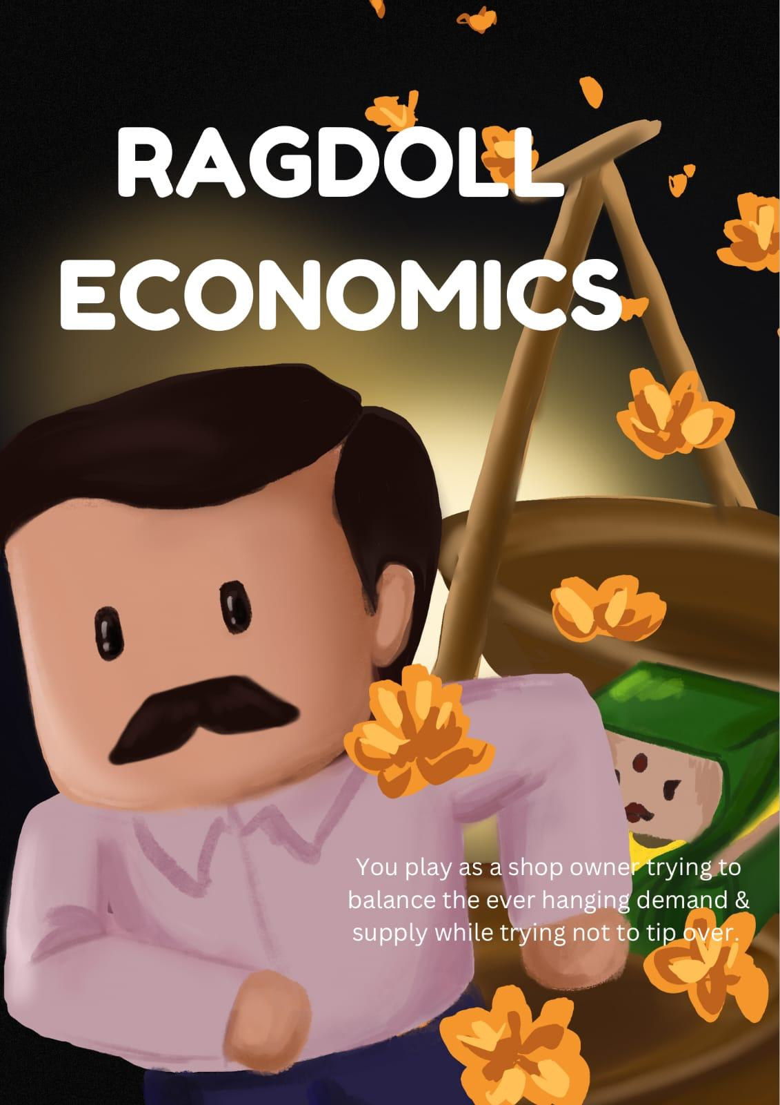
Figure 8. Ragdoll Economics, the design concept developed from the research. Reproduced from the original project presentation.
The concept also gives form to the central role of reselling. Informal vendors connect supply to buyers in a way that creates movement through the market, while every additional transaction introduces another decision and another risk. The game is not a direct economic model. It simplifies a complex system into a set of rules that can be understood through play, and it should be treated as a communication device rather than evidence that the market functions exactly like a balancing platform.
The project did not establish through testing that players would understand the economics accurately, and the game concept does not account for all the conditions documented in the fieldwork. In particular, it simplifies licensing uncertainty, the use of public space, differences in negotiating power, and the specific operating costs carried by vendors. These are important limitations if the concept is developed further. Its value at this stage is that it translates price and demand uncertainty into an accessible design form while keeping the relationship between supply, buyers, and risk at the centre.

8. Limitations and evidence boundaries
This study is based on a small, exploratory sample collected over four to five days. The interviews and conversations provide a view into the experiences of selected formal traders, informal vendors, and buyers, but they do not represent every seller or customer at Jamalpur. Access to owners was difficult because of the demands of trading, and some workers who were available had limited information about sourcing, pricing, and wider business arrangements.
The study did not collect sales ledgers, receipts, household income records, or comparable financial data. It therefore cannot calculate the informal market’s total contribution, prove that roadside sellers stabilise shop revenue during low-demand periods, or establish what share of sales occurs outside. The evidence suggests an economically useful connection and identifies possible mechanisms, but the size of the effect remains unknown.
The card-sorting materials preserve some prompts and categories but not a complete set of individual rankings. This limits what can be reported about the relative priority of expenses. Likewise, municipal and police enforcement was discussed and observed only within a short fieldwork period, so the study cannot estimate how often vendors are asked to move. Finally, the legal status of individual stalls and the details of commission arrangements were not independently verified. These are not minor gaps to be filled with assumptions; they define the limits within which the findings should be read.

9. Conclusion
This study set out to understand whether informal vending plays an important economic role in Jamalpur Flower Market. The fieldwork suggests that it does. Roadside vendors buy flowers from permanent shops, resell them to buyers who value quick access, and contribute to a wider network of livelihoods and support services. Their activity extends the market beyond its fixed shops and helps explain why the area remains commercially active across different times of day.
That contribution exists alongside real tensions. Roadside vending overlaps with traffic, vendors do not have the same secure position as the permanent shops, and municipal or police visits can interrupt their work. The relationship is therefore neither fully informal and disconnected nor fully recognised and secure. It is interdependent, useful, and precarious at once.
The main conclusion is that the economic importance of the informal market is visible in the relationships it enables, even though its total financial value remains unmeasured. Understanding Jamalpur requires attention to the flowers moving through the market, but also to the people, services, spaces, and practical decisions that make those transactions possible. Any future research or intervention should hold these connections together rather than treating roadside vending only as an issue of congestion or legality.

References
Ahmedabad Municipal Corporation. (n.d.). Jamalpur Gate [Heritage listing including Jamalpur Flower Market]. AMC Heritage City. https://heritage.ahmedabadcity.gov.in/details/87/heritage_site/en
Arora, S. (2026, June 22). Jamalpur flower market Ahmedabad: History, location, shops, famous for. The Market Inputs. https://www.themarketinputs.com/jamalpur-flower-market-ahmedabad/
Bhadra, N. (2023, December 3). Know your city: ‘Capital of flower markets’, Ahmedabad’s Jamalpur Bazaar relies on vendors’ bonds, customers’ joy. The Indian Express. https://indianexpress.com/article/cities/ahmedabad/gujarats-flower-markets-ahmedabads-jamalpur-bazaar-9052496/
Government of India. (2014). The Street Vendors (Protection of Livelihood and Regulation of Street Vending) Act, 2014 (Act No. 7 of 2014). India Code. https://www.indiacode.nic.in/bitstream/123456789/19057/1/sv_act_2014.pdf
Jani, Z. (2026, March 30). From the quiet Fulgali to the bustling Jamalpur Flower Market: The tale of Ahmedabad’s Phool Bazar. Knocksense. https://www.knocksense.com/ahmedabad/from-the-quiet-fulgali-to-the-bustling-jamalpur-flower-market-the-tale-of-ahmedabads-phool-bazar/
PRS Legislative Research. (2020). The Gujarat Agricultural Produce Markets (Amendment) Ordinance, 2020. https://prsindia.org/bills/state-legislative-briefs/the-gujarat-agricultural-produce-markets-amendment-ordinance-2020
Sekhani, R., Mohan, D., & Medipally, S. (2019). Street vending in urban ‘informal’ markets: Reflections from case-studies of street vendors in Delhi (India) and Phnom Penh City (Cambodia). Cities, 89, 120–129. https://doi.org/10.1016/j.cities.2019.01.010

Appendix A. Additional field photographs
These photographs were taken during my visits to Jamalpur Flower Market and are included to document the physical setting observed during fieldwork.
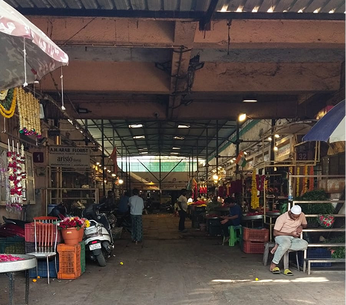
Figure A1. View through the main aisle of the market hall. Photograph by the author.
The shopfronts and flower stock are also part of the market’s everyday working environment.
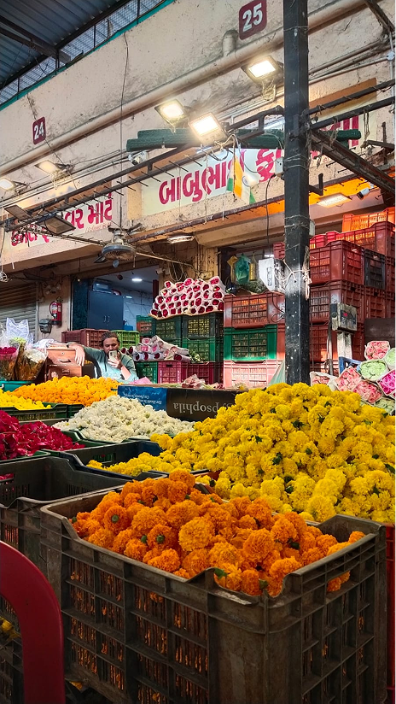 | 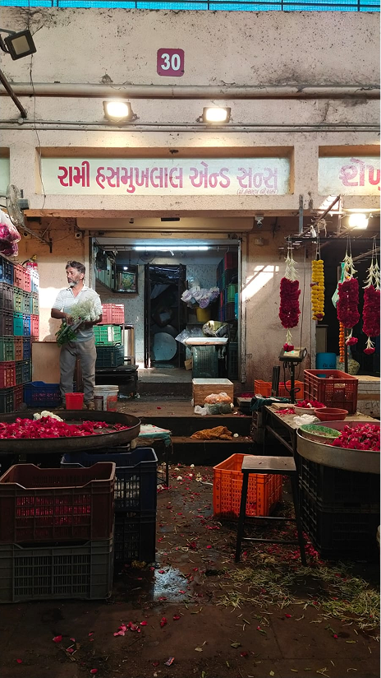
Figure A2. Flower stock and the frontage of a permanent shop. Photographs by the author.

